**Name:** Kyle Choi **Date:** 3/21/2022 **Max points:** 25

**Lab section:** Wednesday 9:30

**Show your work!!!**

**Acquire**

Week: 48

Date: Nov 25 Year: **2019** Data: 2018 Central Park Squirrel Census Fur Map

**Source Article/Visualization:**

[2018 Central Park Squirrel Census Fur Map](https://data.cityofnewyork.us/Environment/2018-Squirrel-Census-Fur-Color-Map/fak5-wcft)  
Data Source: [NYC Open Data](https://data.cityofnewyork.us/Environment/2018-Central-Park-Squirrel-Census-Squirrel-Data/vfnx-vebw)<https://www.makeovermonday.co.uk/data/data-sets-2016/>

**Represent**

**Critique**

This visualization of all the squirrels in NYC’s Central Park is a great visualization that gets interactive as you zoom in. However, my main gripe with this visualization is that there are too many data points that are too close together. I realize that the data is meant to represent every single squirrel in Central Park, but I find that ridiculous, frankly, as there are far too many squirrels in Central Park to justify plotting every single one of them. This visualization falls within the information visualization category, as the visualization is a map of Central Park. It is also interactive, as you can zoom in to specific places of interest and see, to a greater extent, where squirrels reside.

**Mine**

Where are squirrels most densely populated in Central Park?

**Filter**

**Stakeholders**

* Audience
  + NYC Public
  + Park Rangers
  + NYC Department of Environmental Protection
* Assumptions
  + Squirrels and chipmunks are differentiated
  + Squirrels exist exclusively in Central Park, and not outskirts
  + There is no human interference with squirrel’s habitats
* Visualization Tool
  + Tableau

**NEW Sketch your Makeover**

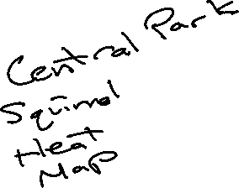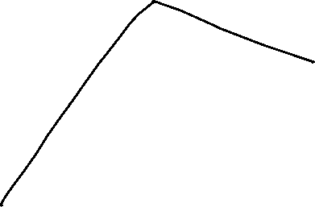

**Refine (Makeover – Portrait View)**

Heat map of squirrel density in Central Park

**Resources**

Data Visualization Checklist:

<http://stephanieevergreen.com/wp-content/uploads/2016/10/DataVizChecklist_May2016.pdf>

How to give constructive criticism:

<https://personalexcellence.co/blog/constructive-criticism/>

Sample Makeovers

<https://www.makeovermonday.co.uk/gallery/>

**Grading Rubric**

|  |  |  |  |
| --- | --- | --- | --- |
| **Excellent** | **Good** | **Fair** | **Needs Improvement** |
| Meets **ALL** or most of these: Makeover is esthetically pleasing (color, perception), best practices followed (insightful), Correct dataset downloaded; provided an interesting point of view of the data; critiqued previous makeover, critique is constructive (indicates one thing that is done well, and one thing that could be done differently, what will be done to improve the visualization), assumptions (more than one) are listed.  [15 pts] | Meets **MOST** of these: Makeover is esthetically pleasing (color, perception), best practices followed (insightful), Correct dataset downloaded; provided an interesting point of view of the data; critiqued previous makeover, critique is constructive (indicates one thing that is done well, and one thing that could be done differently, what will be done to improve the visualization), assumptions (more than one) are listed.  [10 – 14 pts] | Consistently meets **SOME** of these: Makeover is esthetically pleasing (color, perception), best practices followed (insightful), Correct dataset downloaded; provided an interesting point of view of the data; critiqued previous makeover, critique is constructive (indicates one thing that is done well, and one thing that could be done differently, what will be done to improve the visualization), assumptions (more than one) are listed.  [5 – 9 pts] | Little to no evidence of the understanding of the data visualization process.  Lackluster makeover or no makeover.  Little effort.  [0 – 4 pts] |
| Sketch included: hand drawn, data vis best practices evident.  [5 pts] | Sketch included: hand drawn, lacking data vis best practices.  [3 pts] | Sketch included, but was generated by computer  [2 pts] | No sketch included.  [0 pts] |
| More advanced chart types used  [5 pts] | More advanced chart types used, followed most best practices  [3 pts] | Basic chat types used in the makeover  [2 pts] | Little to no improvement in visual representation of the data [0 pts] |